**EXERCISE 1**

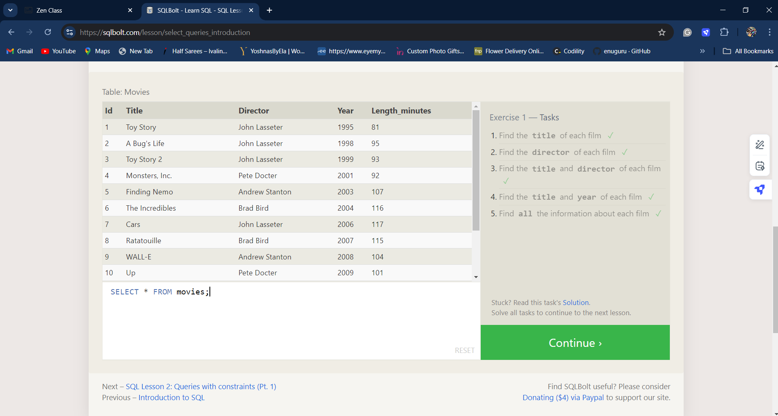

**EXERCISE 2**

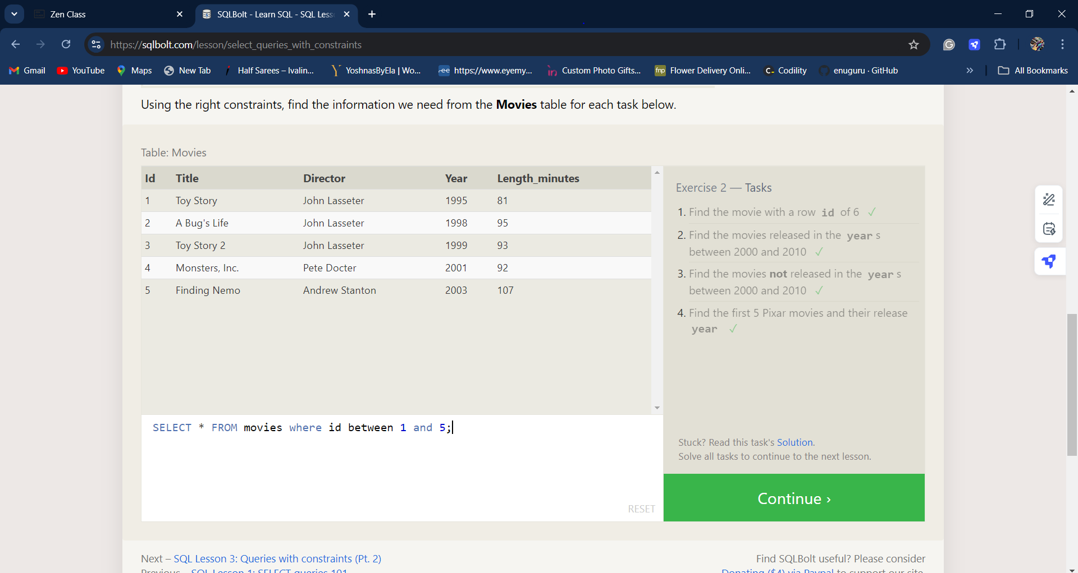

**EXERCISE 3**

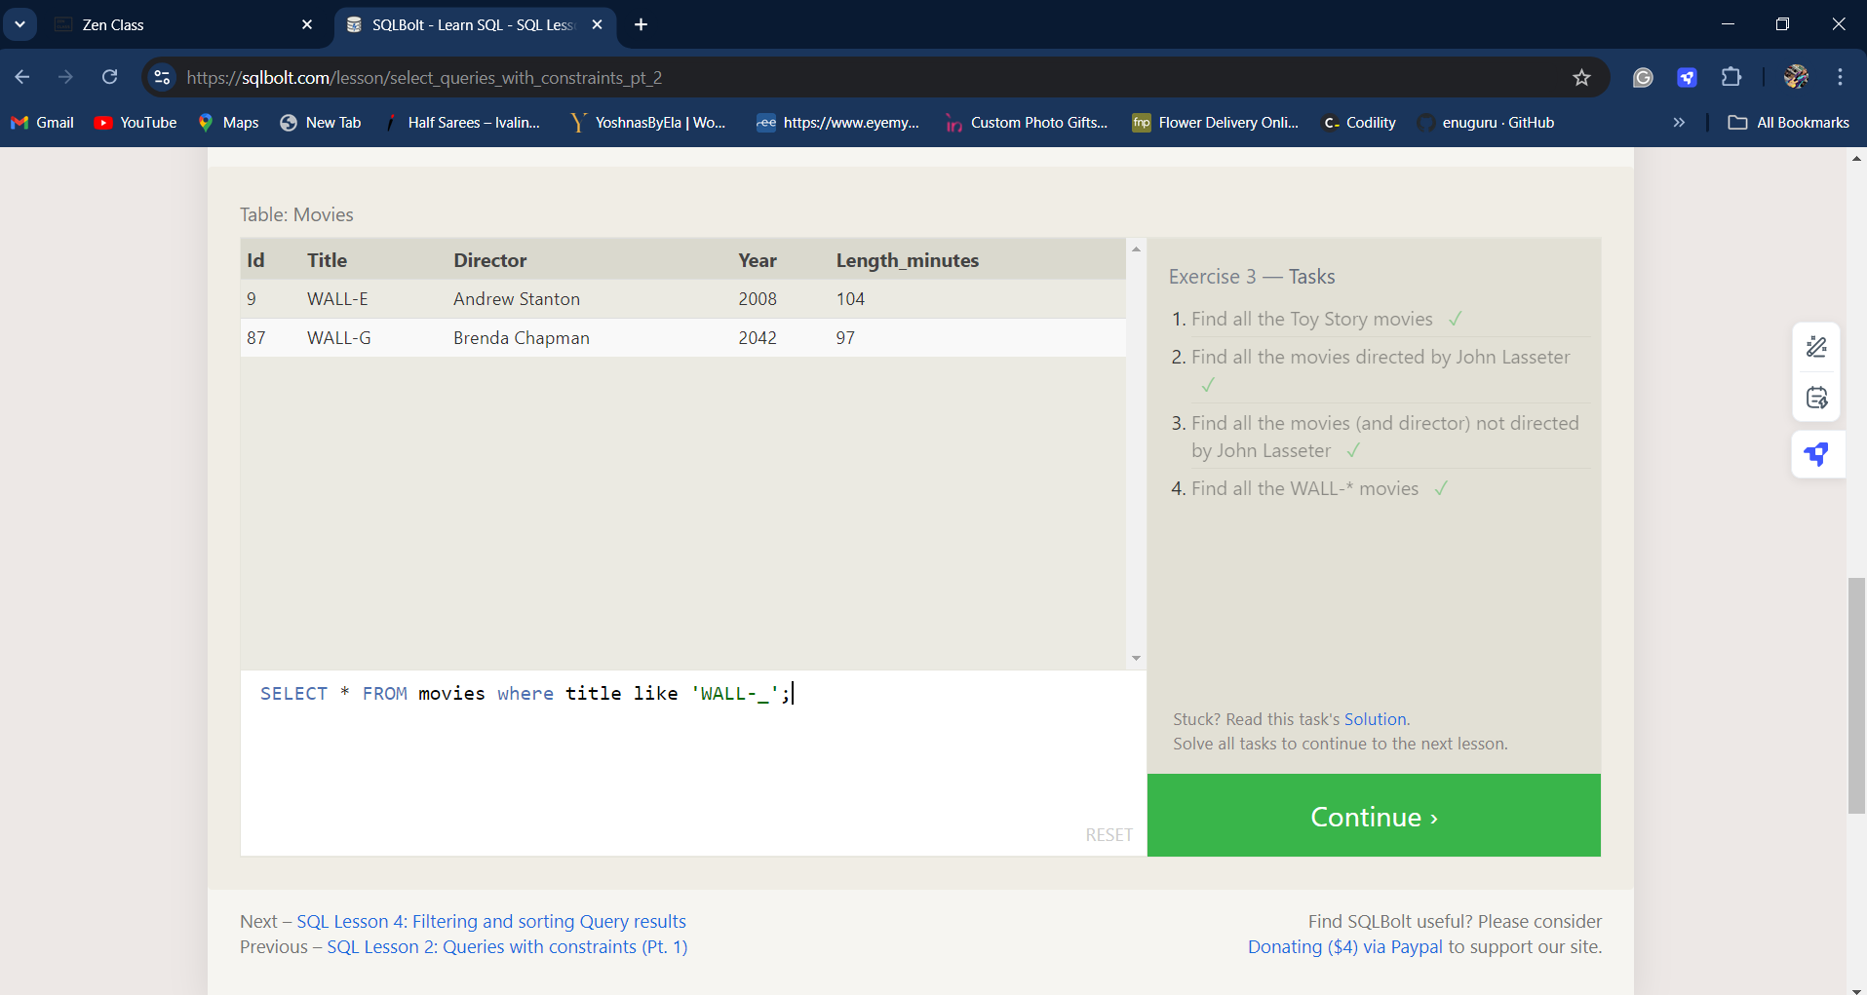

**EXERCISE 4**

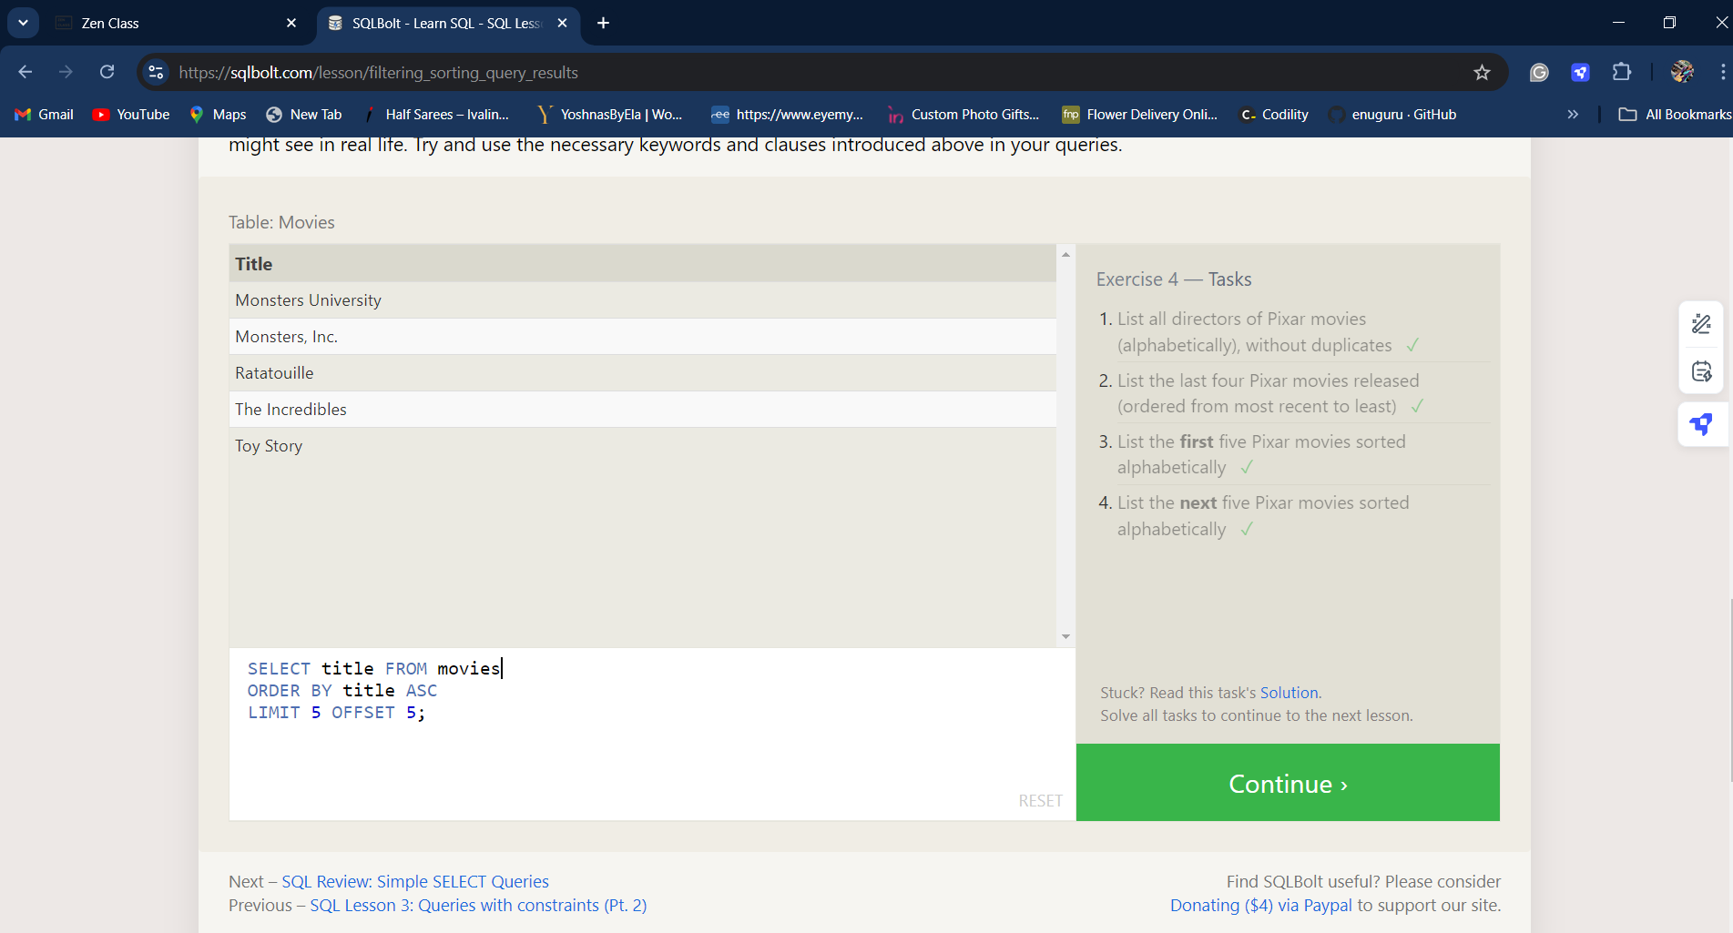

**REVIEW 1**

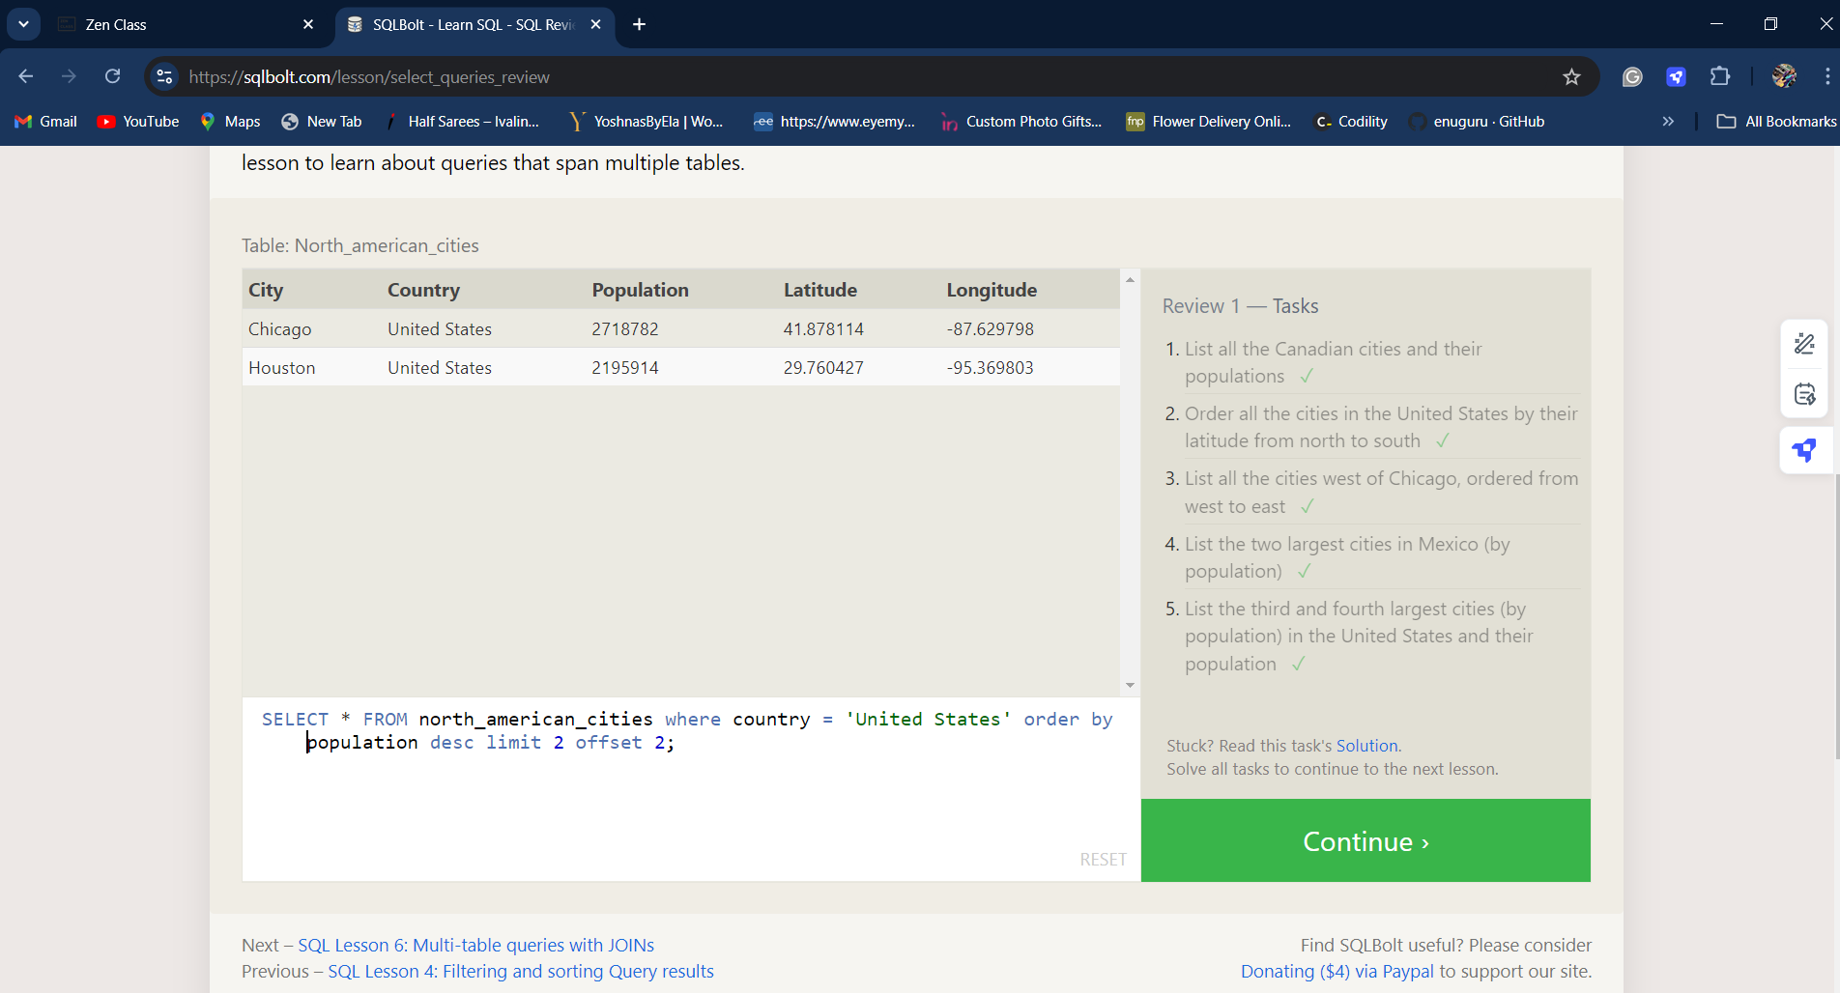

**EXERCISE 6**

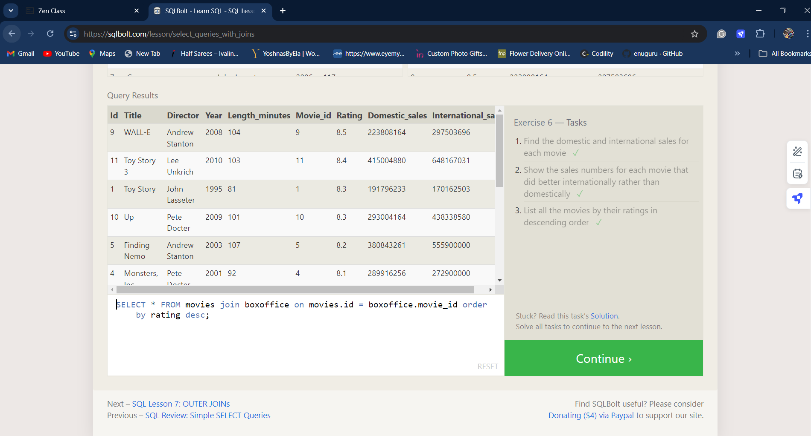

**EXERCISE 7**

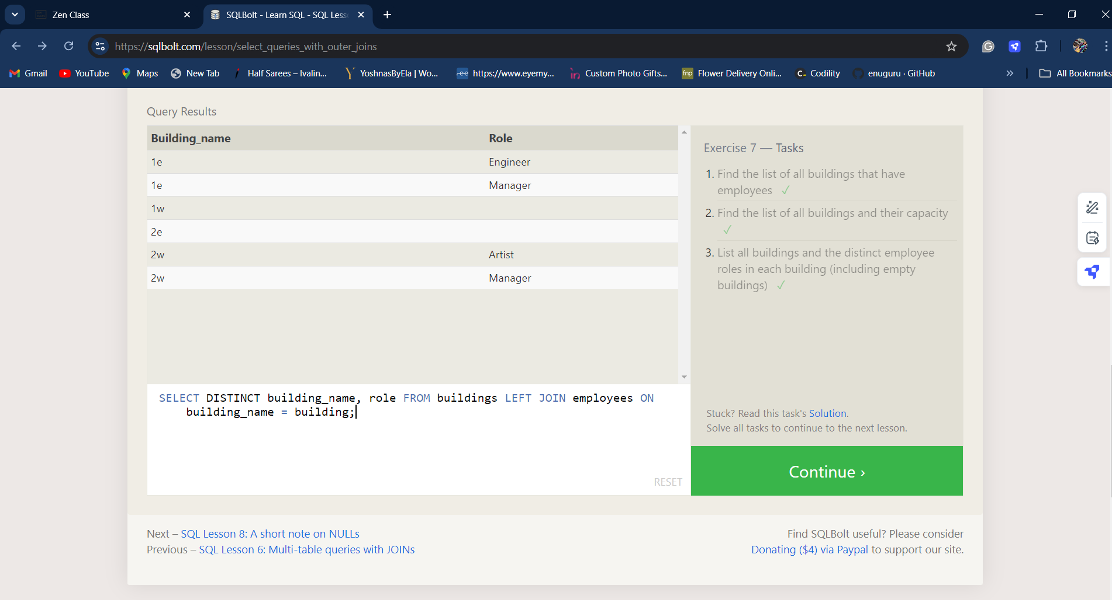

**EXERCISE 8**

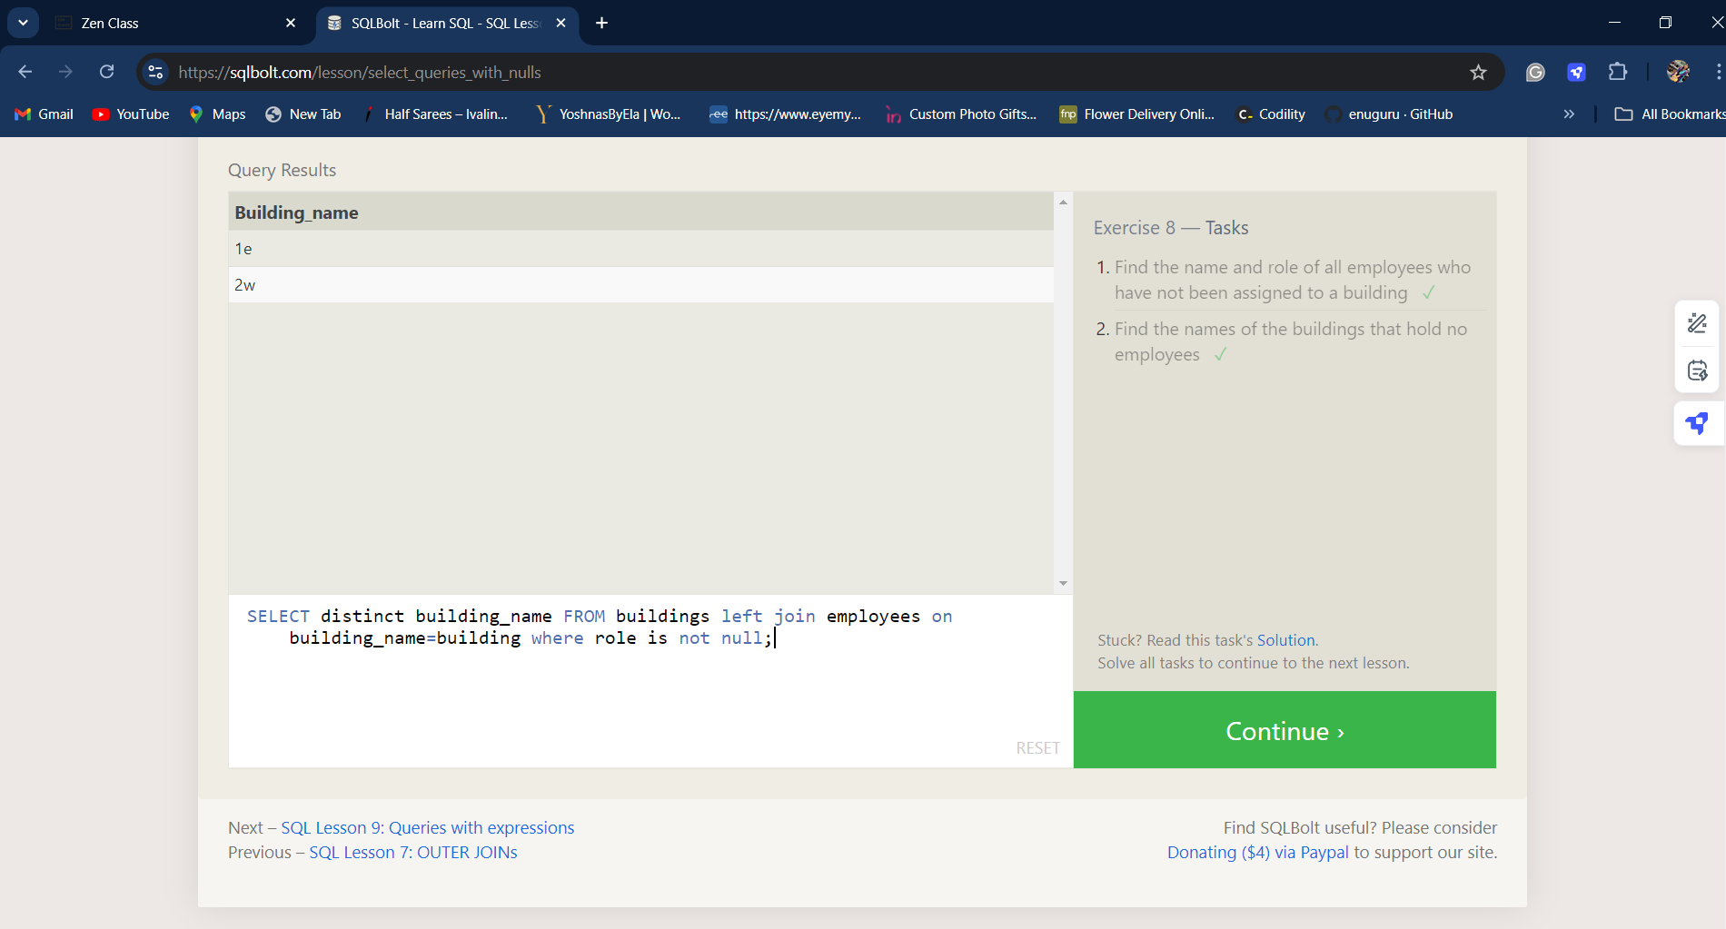

**EXERCISE 9**

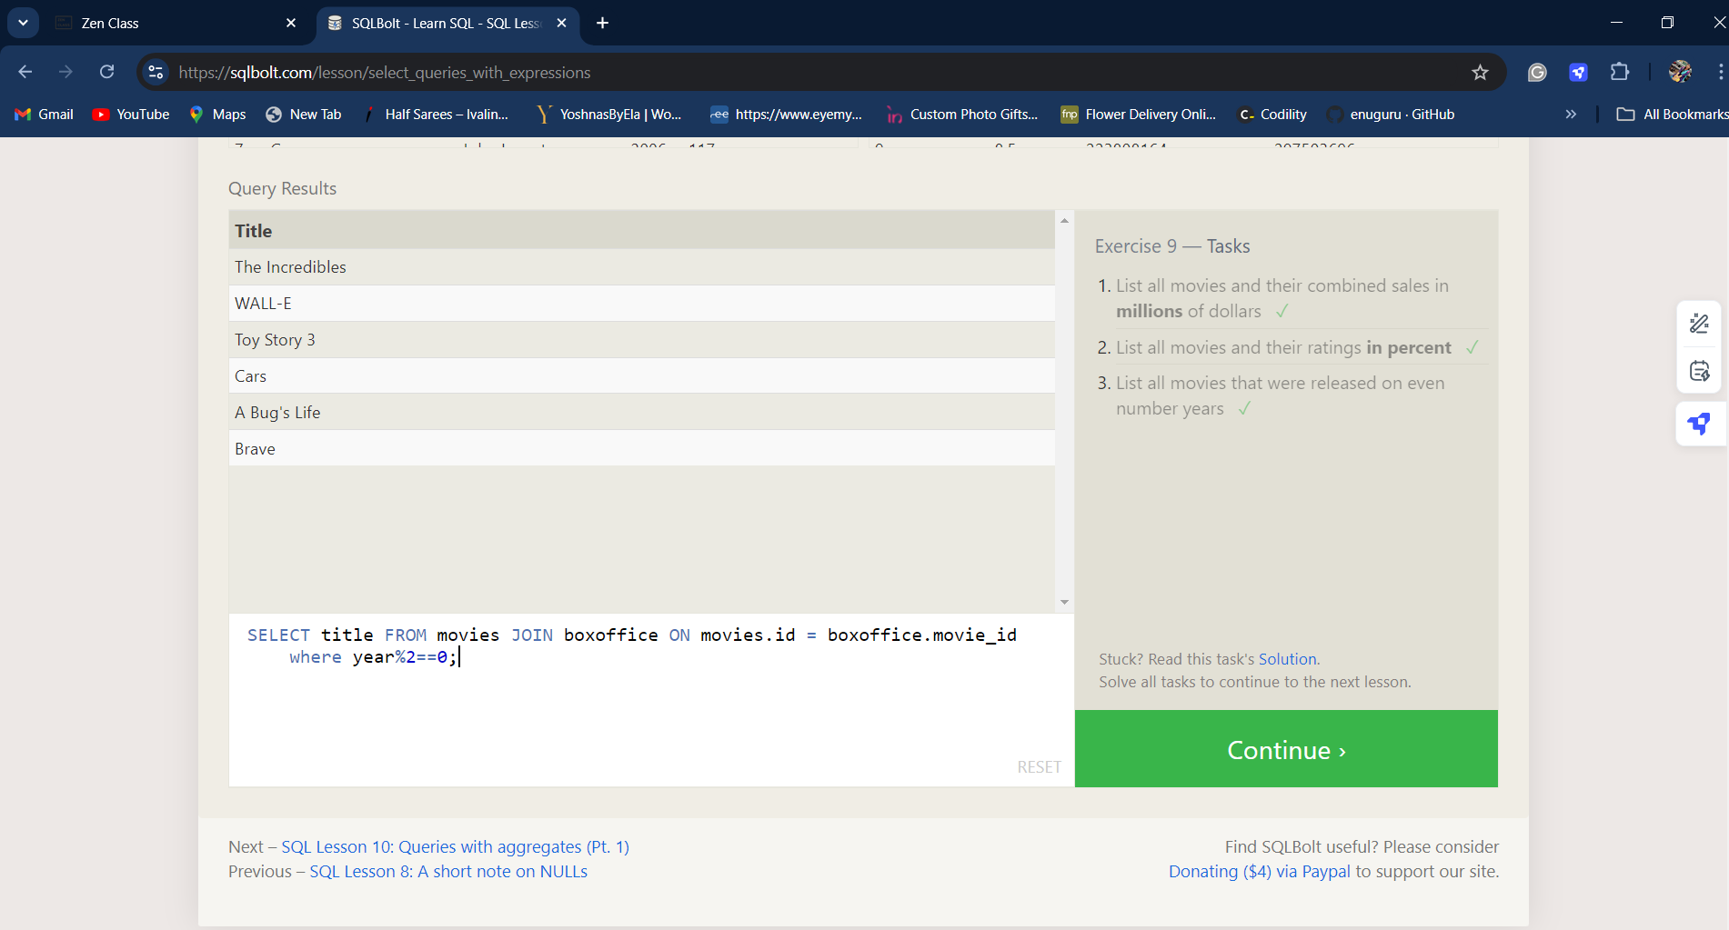

**EXERCISE 10**

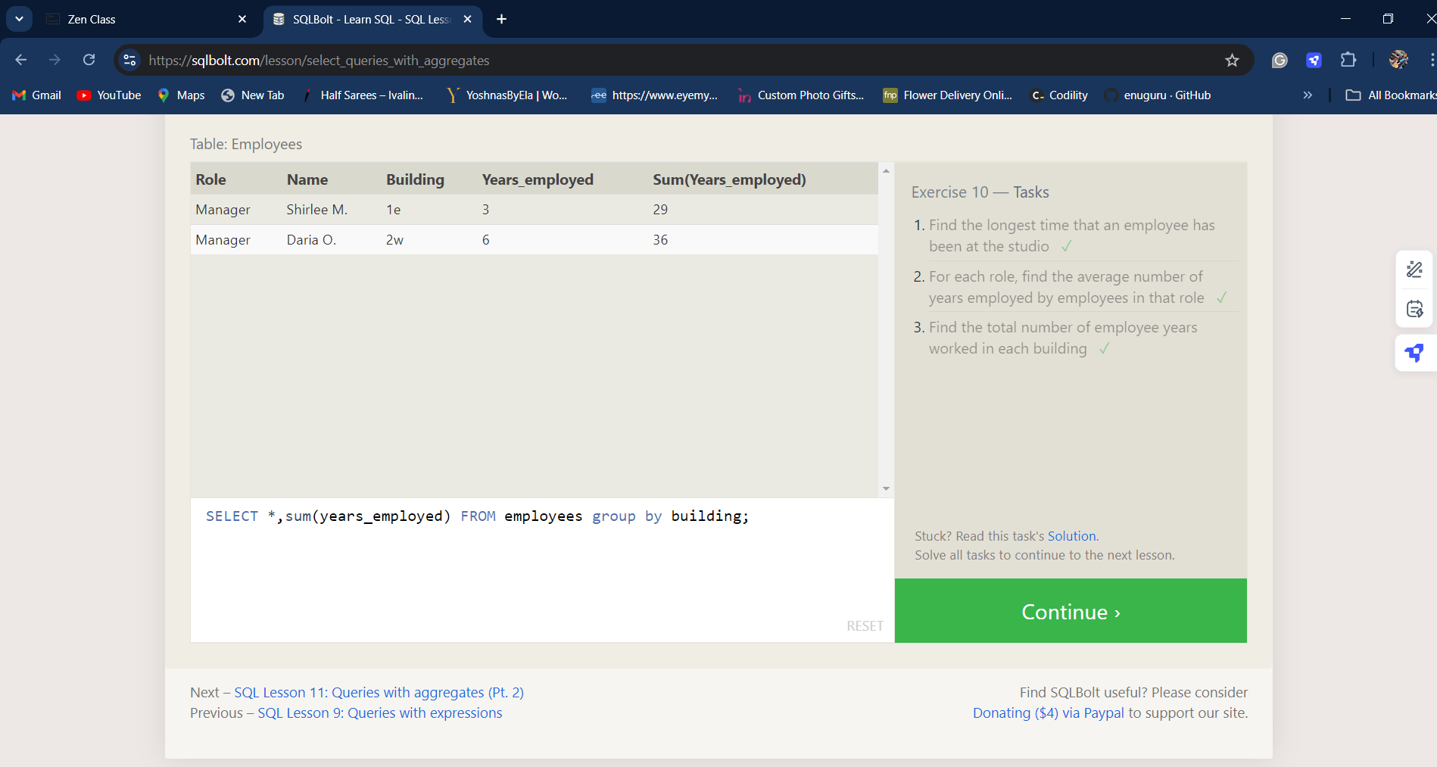

**EXERCISE 11**

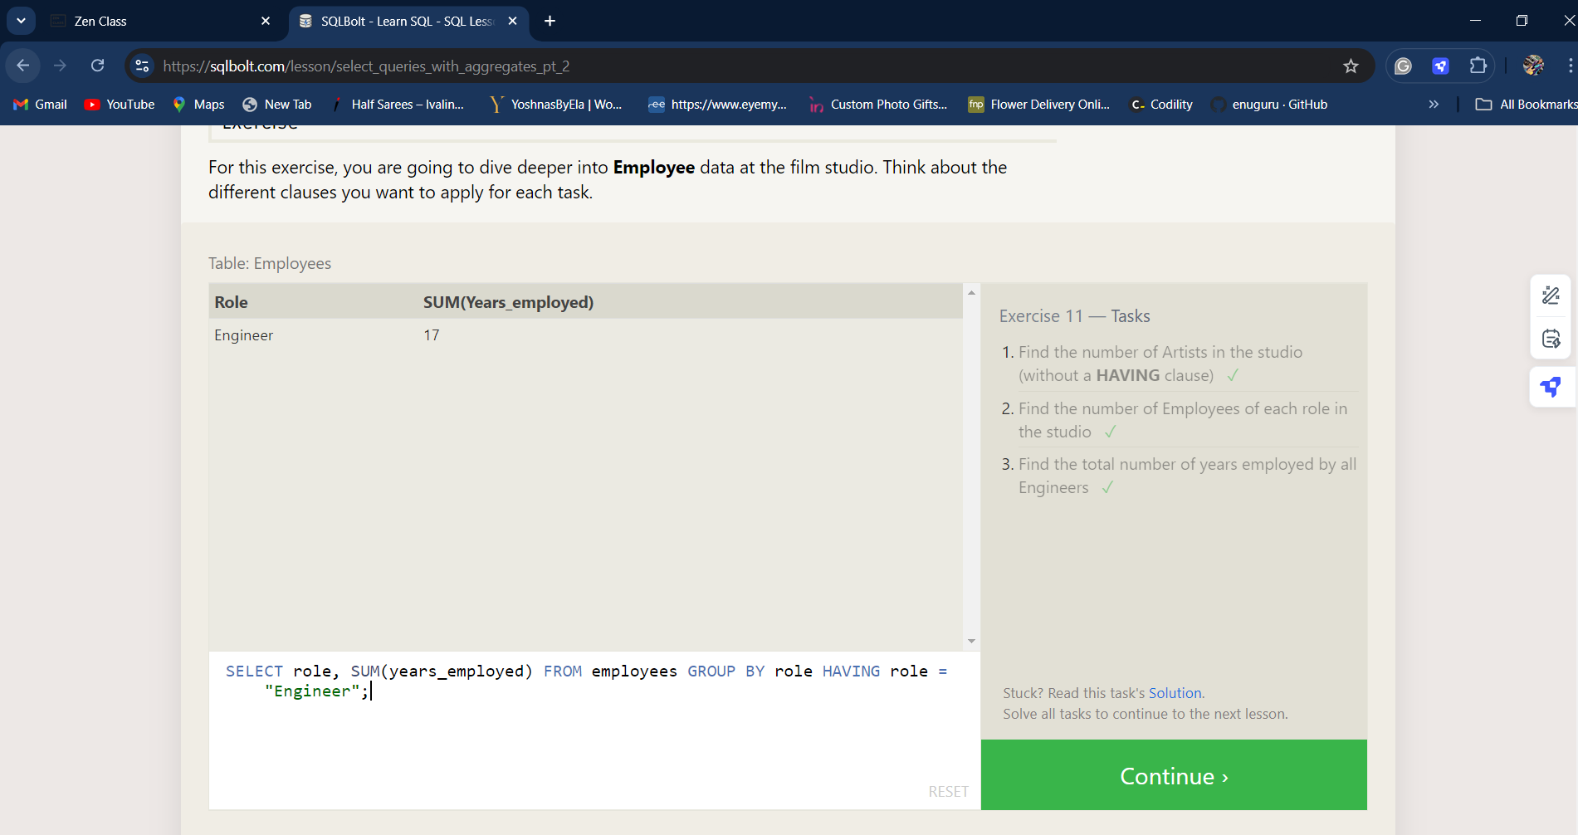

**EXERCISE 12**

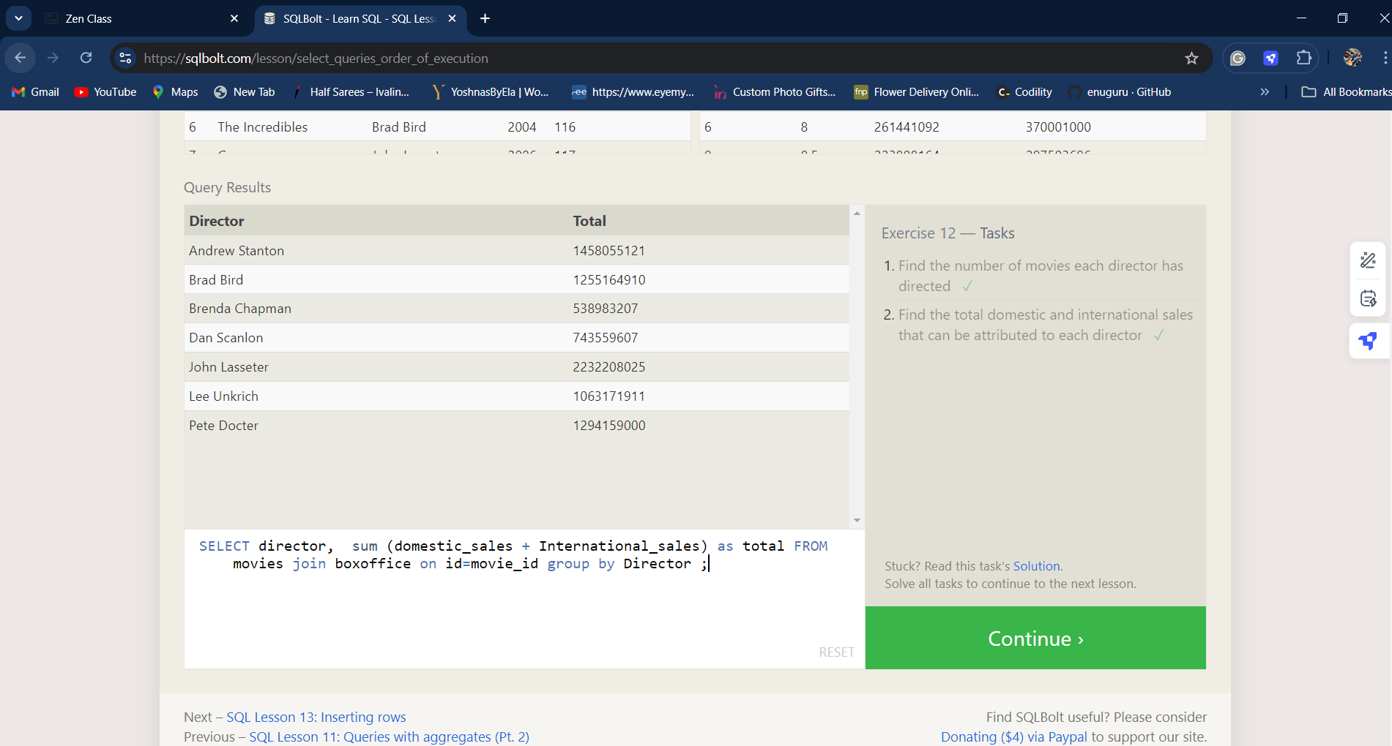

**EXERCISE 13**

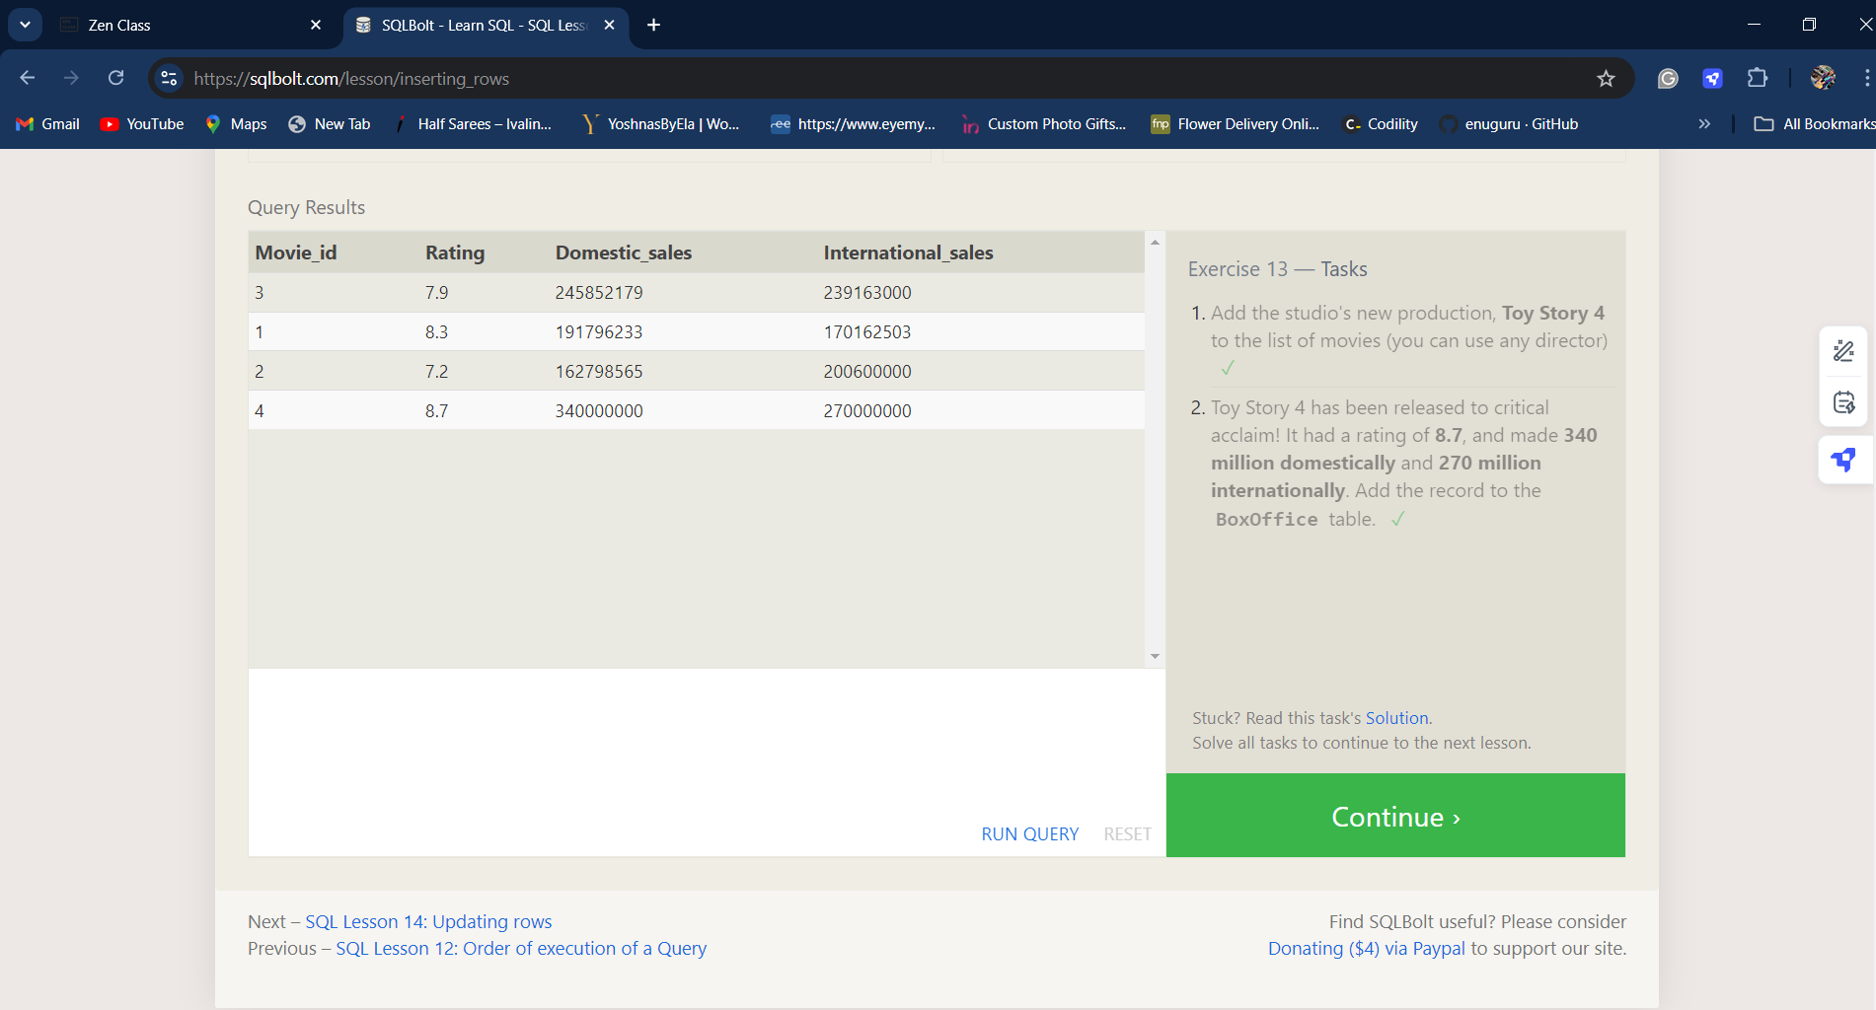

1. INSERT INTO movies VALUES (4, "Toy Story 4", "Pete Docter", 2015, 90);
2. INSERT INTO boxoffice VALUES (4, 8.7, 340000000, 270000000);

**EXERCISE 14**

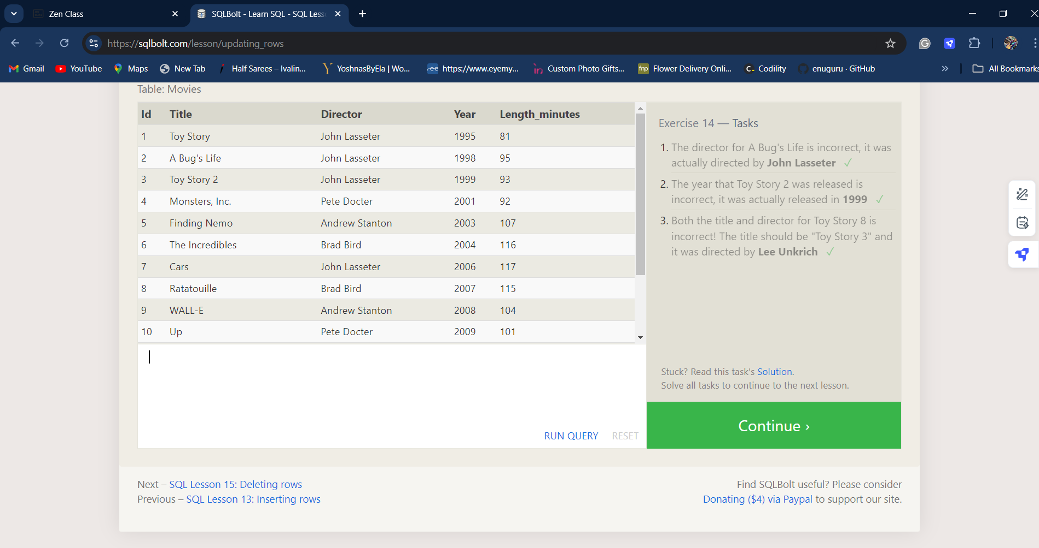

1. UPDATE Movies set Director = 'John Lasseter' where Title = "A Bug's Life"
2. UPDATE Movies set year = 1999 where Title = "Toy Story 2"
3. UPDATE Movies set Title = "Toy Story 3",Director='Lee Unkrich' where Title = "Toy Story 8"

**EXERCISE 15**

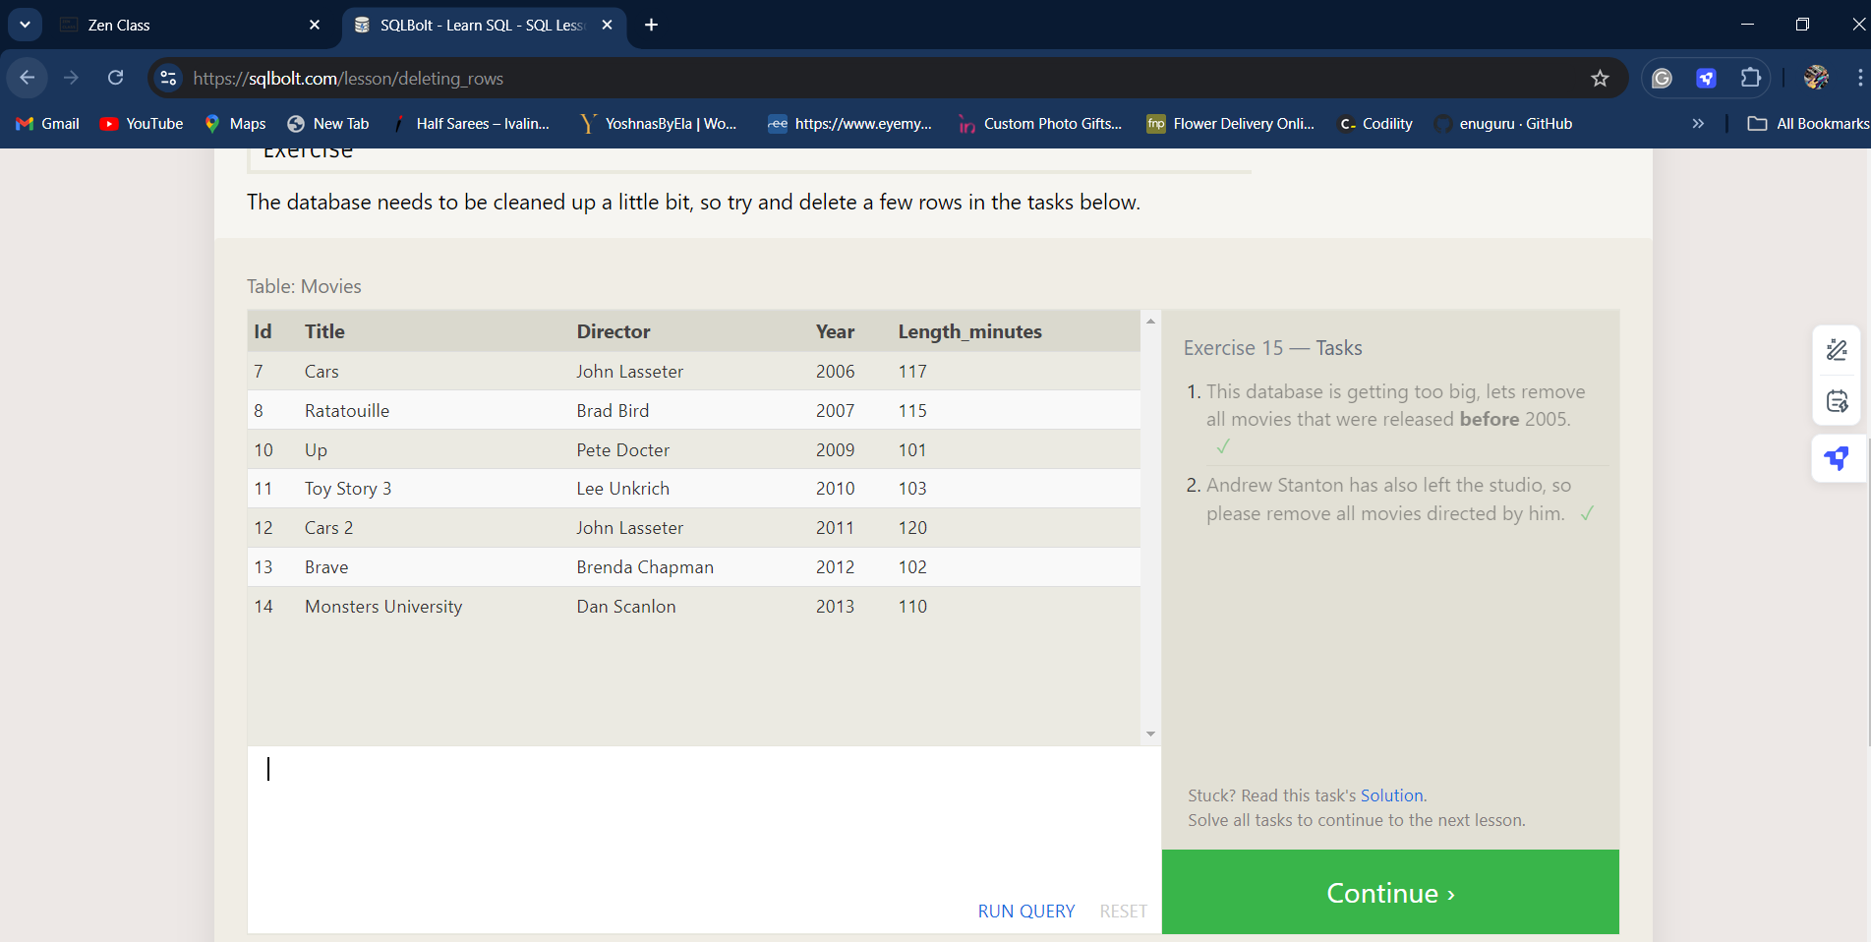

1. DELETE from Movies where year<2005;
2. DELETE from movies where director=”Andrew Santon”;